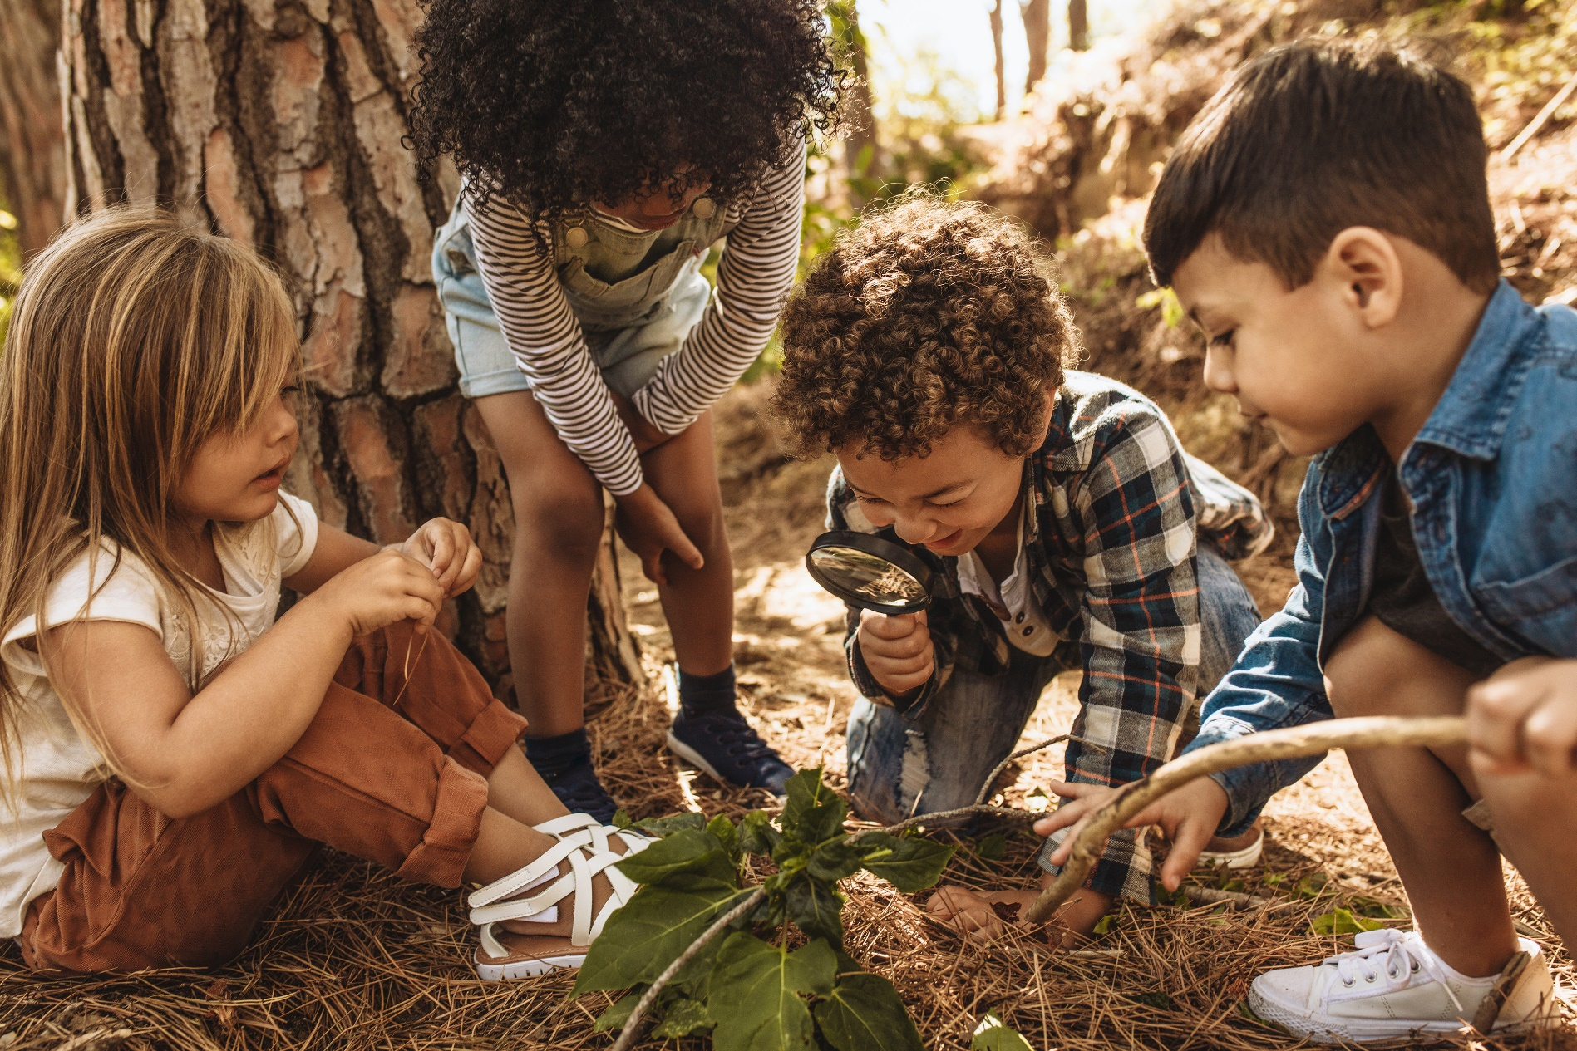
=

Preschool Assessment Form
Parents, please complete the following questions about your child. Thank you!

Parent’s Name: Child’s Name:
On a scale from 1-5 in which 1 means “Never” and 5 means “Always” describe your child’s current ability with the following.
 | 1. | Our child uses the toilet without help from an adult.
 | 2. | Our child can..
 |  | a. | Zip
 |  | b. | Use snaps
 |  | c. | Button him or herself
 | 3. | Our child dresses him or herself.
 | 4. | Our child voices clearly his or her needs.
 | 5. | Our child plays well independently.
 | 6. | Our child plays well with other children.
 | 7. | Our child takes turns with toys.
 | 8. | Our child completes tasks when asked.
 | 9. | Our child initiates and completes tasks on his or her own.
 | 10. | Our child uses aggressive behaviors when interacting with others.

More On Your Child
What does a normal day for your child look like?

Does he or she have medical allergies or needs that we need to be aware of? If so, please explain.

Does your child struggle with extreme fears or anxieties? If so, please explain.

Does he or she experience any speech problems or delays? If so, are there services being provided? Please explain.

Final Questions
Our child has shown interest in the following:

____ using scissors to cut ____ writing ____ coloring

____ drawing ____ reading books ____ counting numbers

____ naming numbers ____ naming letters of the alphabet

____ holding pencil with finger ____ cleaning up after him or herself

How many shapes can your child identify? _____
Please list which shapes:

Please check off the statements below as it applies to your child.

Our child can:
____ run
____ hop
____ skip
____ hop on one leg
____ throw a ball
____ catch a ball

What makes your child feel the happiest?

Are there rhythms or strategies used at home that your child responds really well to? If so, please explain.

Does he or she have favorite colors yet? If so, what are they?

How does your child like to be celebrated? (high five, words of praise, one-on-one time together, special notes, etc)

